Sanima Capital

Sama Marga, Naxal, Kathmandu, Nepal

Meeting no:126

Meeting Date: August 19, 2025

Minute prepared by: Research Department

Discussion Topic: Meeting on Development Bank as of Q4

|  |  |  |  |
| --- | --- | --- | --- |
| Name | Signature | Attendance | Comment |
| Bhism Raj Chalise |  | Yes No  Noted |  |
| Poskar Basnet |  | Yes No  Noted |  |
| Akhilesh Bikram Sthapit |  | Yes No  Noted |  |
| Punya Ram Kasichhwa |  | Yes No  Noted |  |
| Dinesh Singh Mahat |  | Yes No  Noted |  |
| Pratistha Gautam |  | Yes No  Noted |  |
| Abin Neupane |  | Yes No  Noted |  |
| Anil Siwakoti |  | Yes No  Noted |  |
| Anup Acharya |  | Yes No  Noted |  |

**Seasonality of development bank index**

# 

# Industry summery of Development Banks (National Level)

## PE vs PB Scatter Plot as of Q4 Report

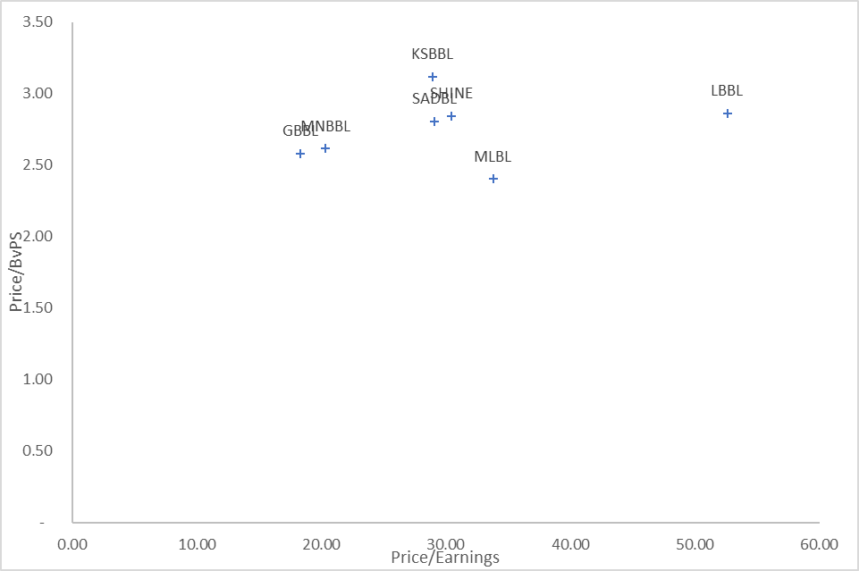

The scatter plot is a useful way to quickly compare development banks in terms of how the market values their earnings and assets. By examining the P/E and P/B ratios together, we can better understand market expectations, identify undervalued opportunities, or confirm strong growth investments. Each quadrant or position in the scatter plot reflects different investment appeals, from growth to value to balanced approaches.

**Analysis of NPL**

|  |  |  |  |
| --- | --- | --- | --- |
| ABB | Non Performing Loan (NPL) to Total Loan 2024/25Q4 | Non Performing Loan (NPL) to Total Loan 2023/24Q4 | Growth |
| GBBL | 4.72% | 2.89% | 63.3% |
| JBBL | 7.98% | 4.95% | 61.2% |
| LBBL | 4.55% | 3.29% | 38.3% |
| SADBL | 5.64% | 4.08% | 38.2% |
| SHINE | 4.24% | 3.43% | 23.6% |
| MNBBL | 2.75% | 2.26% | 21.7% |
| MLBL | 4.86% | 4.58% | 6.1% |
| KSBBL | 3.38% | 3.21% | 5.3% |

As of December 2024, Karnali Development Bank faced significant financial challenges. The Nepal Rastra Bank (NRB) declared it a "crisis-ridden" institution due to several critical issues mostly due to non-performing loan (NPL) ratio of 40.85%. Due to which the report of the KRDBL is not included in the analysis.

The development banking sector of Nepal is experiencing a concerning deterioration in asset quality, with Non-Performing Loan (NPL) ratios increasing significantly across the board. Current NPL levels ranging from 2.75% to 7.98% indicate varying degrees of portfolio. JBBL faces a double burden - both the highest baseline NPL ratio (7.98%) AND the second-highest growth rate (61.2%). MNBBL has higher Lower NPL compared to the other development bank of Nepal.

**ROE vs ROA Analysis**

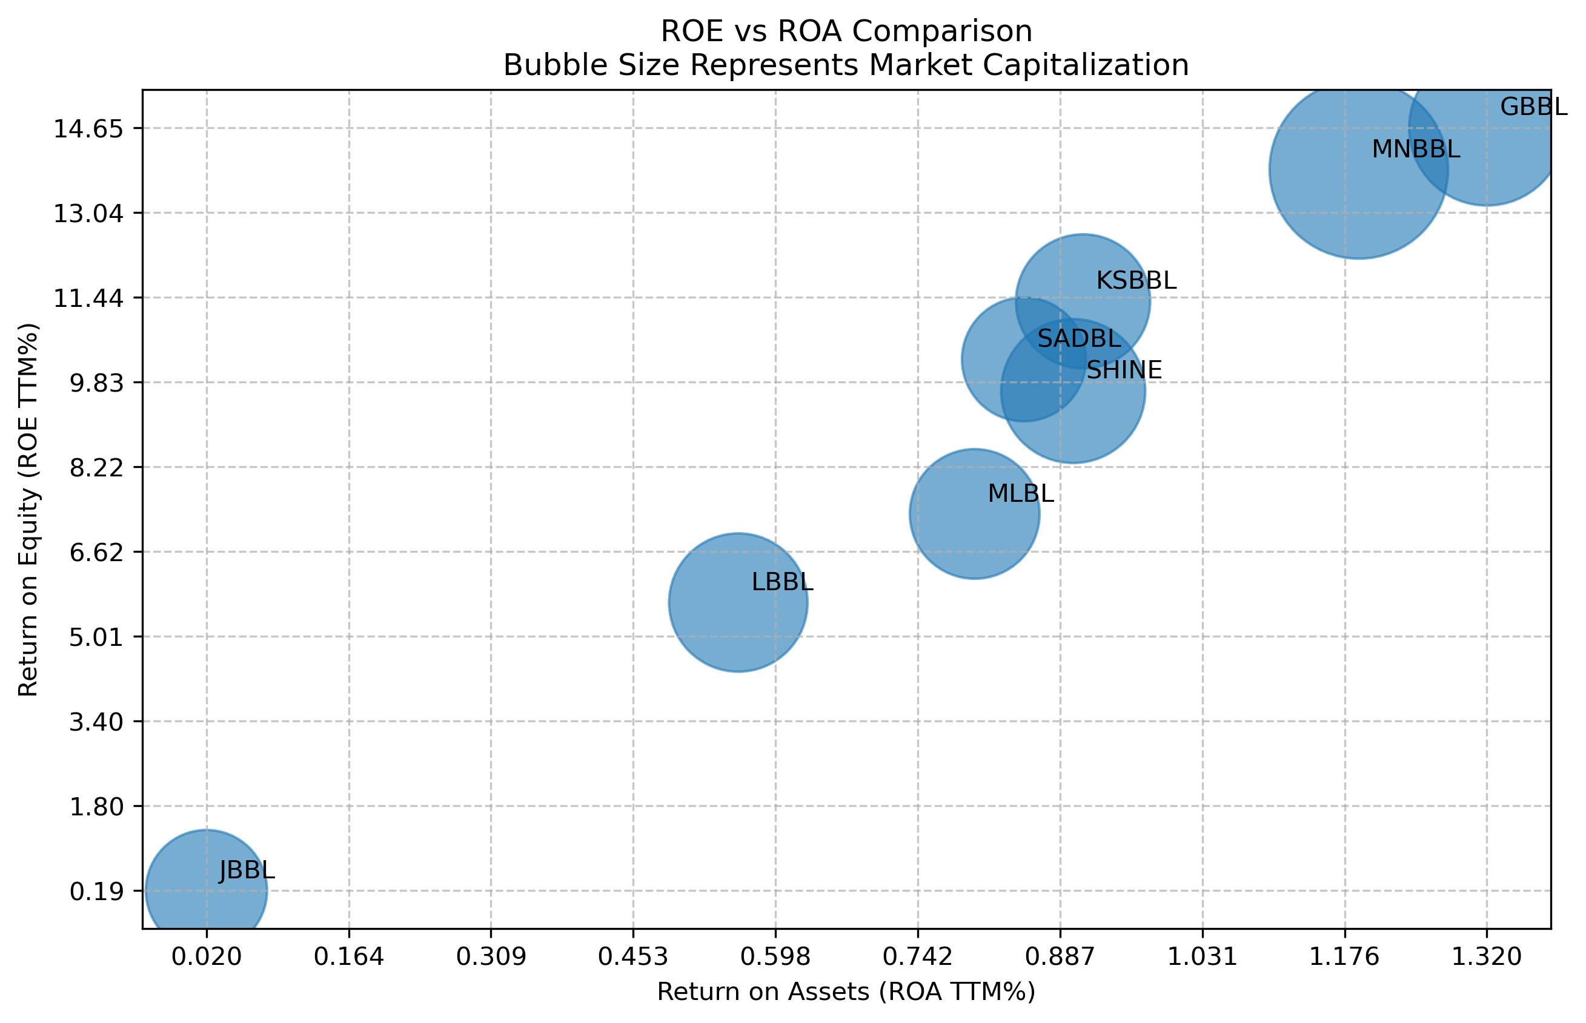

This visualization compares banks using three key financial metrics: Return on Assets (ROA)(TTM) on the x-axis shows how well banks use their assets to generate income, Return on Equity (ROE)(TTM) on the y-axis indicates profitability from shareholders' perspective, and bubble size represents each bank's market capitalization. The combination of these metrics provides a comprehensive view of bank performance, where higher ROA indicates better asset utilization, higher ROE suggests stronger returns for shareholders, and bubble size gives context about the bank's relative market value.

GBBL & MNBBL: Dominate the upper-right quadrant with ROE ~14.5% and strong ROA >1.2%.These institutions demonstrate exceptional profitability and efficient asset utilization. Large bubble sizes indicate substantial market capitalizations.

KSBBL, SADBL, SHINE: Clustered in solid performance territory (ROE 9-11%, ROA 0.85-0.95%)

Balanced risk-return profiles with respectable market recognition

Underperformers: **LBBL:** Lower performance tier (ROE ~5%, ROA ~0.55%) indicating operational challenges. **JBBL:** Catastrophic positioning - near-zero ROE (~0.2%) and minimal ROA (~0.02%)

**Dividend Capacity**

**Summary of the Report with relative valuation**

|  |  |  |  |  |  |  |  |  |  |
| --- | --- | --- | --- | --- | --- | --- | --- | --- | --- |
| ABB | DDPS (Q4 Total) | Div yield | ICPS (Q4) adjusted to tax | EPS as of Q4 2024/25 | EPS as of Q4 2023/24 | BVPS | Price | Price/ Earnings | Price/ BvPS |
| GBBL | 12.59 | 2.97% | 9.47 | 23.1 | 20.0 | 164.2 | 423.64 | 18.36 | 2.58 |
| KSBBL | 17.30 | 3.30% | 11.89 | 18.1 | 17.2 | 168.1 | 524.05 | 28.96 | 3.12 |
| SADBL | 11.64 | 2.65% | 9.69 | 15.1 | 14.6 | 156.7 | 439.74 | 29.12 | 2.81 |
| MNBBL | 20.75 | 4.67% | 7.99 | 21.8 | 18.2 | 170.0 | 444.48 | 20.37 | 2.62 |
| MLBL | 11.51 | 2.89% | 10.57 | 11.8 | 10.9 | 166.0 | 398.96 | 33.83 | 2.40 |
| SHINE | 13.96 | 3.24% | 18.48 | 14.1 | 14.3 | 151.4 | 430.63 | 30.49 | 2.84 |
| JBBL | (17.75) | -5.14% | 29.20 | 0.3 | 5.6 | 148.8 | 345.75 | 1227.78 | 2.32 |
| LBBL | 8.20 | 1.49% | 18.76 | 10.5 | 16.7 | 192.7 | 551.56 | 52.61 | 2.86 |

**Dividend analysis.**

JBBL (-5.14%) -having the highest NPL ratio (7.98%) and poor profitability metrics

MNBBL (4.67%) - Strong fundamentals (lowest NPL at 2.75%, decent ROE) suggest this capacity is more realistic

**Impairment Charge Analysis.**

* JBBL (29.20) shows catastrophically high impairment charges - nearly 2x higher than any peer. This aligns perfectly with our NPL analysis, confirming JBBL's asset quality crisis
* GBBL (9.47), SADBL (9.69), and MNBBL (7.99) maintain manageable impairment levels. KSBBL (11.89) and MLBL (10.57) show moderate but controllable credit costs

**Valuation analysis**

**Overpriced Stocks:**

* JBBL - Extremely overvalued due to almost no profits (EPS: 0.3) but high stock price
* LBBL - Too expensive at 52x earnings for weak performance
* MLBL - High price (34x earnings) doesn't match average results

Fairly Priced:

* KSBBL, SADBL, SHINE - Trading at 29-30x earnings, reasonable for their good performance

Best Value Picks:

* MNBBL - Great deal at 20x earnings with strong profits (highest EPS: 21.8)
* GBBL - Cheap at 18x earnings despite being sector leader

Book Value Analysis

* Most banks trade at 2.4-2.8 times their book value, which is normal. KSBBL commands highest premium (3.1x) due to best performance.

**EPS and PE without impairment**

|  |  |  |  |  |  |
| --- | --- | --- | --- | --- | --- |
| ABB | ICPS (Q4) | EPS as of Q42024/25 | Price | EPS without ICPS | PE without impairment |
| GBBL | 9.47 | 23.1 | 423.64 | 29.03 | 14.59 |
| KSBBL | 11.89 | 18.1 | 524.05 | 25.59 | 20.48 |
| SADBL | 9.69 | 15.1 | 439.74 | 21.21 | 20.73 |
| MNBBL | 7.99 | 21.8 | 444.48 | 26.85 | 16.55 |
| MLBL | 10.57 | 11.8 | 398.96 | 18.45 | 21.62 |
| SHINE | 18.48 | 14.1 | 430.63 | 25.76 | 16.71 |
| JBBL | 29.20 | 0.3 | 345.75 | 18.67 | 18.51 |
| LBBL | 18.76 | 10.5 | 551.56 | 22.30 | 24.73 |

**Dividend history analysis**

|  |  |  |  |  |  |  |  |  |
| --- | --- | --- | --- | --- | --- | --- | --- | --- |
| Company Name | Bonus (%) 2077-78 | Cash (%) 2077-78 | Bonus (%) 2078-79 | Cash (%) 2078-79 | Bonus (%) 2079-80 | Cash (%) 2079-80 | Bonus (%) 2080-81 | Cash (%) 2080-81 |
| GBBL | 16.00 | 0.00 | 13.00 | 1.50 | 9.50 | 0.50 |  | 5.00 |
| JBBL | 11.00 | 4.50 | 3.00 | 3.80 |  |  |  |  |
| KSBBL | 18.50 | 0.97 | 4.41 | 0.23 |  |  | 7.00 | 5.00 |
| LBBL | 13.00 | 0.68 | 3.00 | 9.00 | 4.00 | 4.50 | 3.00 | 4.00 |
| MLBL | 20.00 | 1.05 | 4.00 | 6.47 |  | 6.40 | 3.00 | 4.00 |
| MNBBL | 17.57 | 0.93 | 13.50 | 0.71 | 9.75 | 0.51 |  |  |
| SADBL | 10.00 | 0.53 | 8.53 | 0.45 | 5.00 | 0.26 | 3.65 | 0.19 |
| SHINE | 10.93 | 0.57 | 13.30 | 0.70 | 10.50 | 0.55 | 3.00 | 5.00 |

## JBBL was not able to give dividend for last two years and MNBBL was not able to give for 1 years.

## NRB reported summery

|  |  |  |  |  |  |  |  |  |  |
| --- | --- | --- | --- | --- | --- | --- | --- | --- | --- |
| Abb | Tire 2 Capital to RWA Q4 | Capital Fund to RWA | Non Performing Loan (NPL) to Total Loan | Total Loan Loss Provision to Total NPL | Credit Deposit Ratio as per NRB Calculations | Cost of Funds | Net Interest Spread | Base Rate | Base rate - COF |
| MLBL | 13.90% | 17.49% | 4.86% | 112.82% | 83.98% | 4.56% | 4.48% | 6.94% | 2.38% |
| JBBL | 8.55% | 13.61% | 7.98% | 100.92% | 83.23% | 4.99% | 3.96% | 7.12% | 2.13% |
| MNBBL | 10.95% | 12.99% | 2.75% | 120.58% | 85.72% | 4.90% | 3.87% | 7.10% | 2.20% |
| SADBL | 11.03% | 14.41% | 5.64% | 81.98% | 83.07% | 5.01% | 4.14% | 7.08% | 2.07% |
| KSBBL | 10.55% | 13.20% | 3.38% | 136.72% | 85.37% | 5.09% | 4.27% | 7.07% | 1.98% |
| SHINE | 11.33% | 12.58% | 4.24% | 97.83% | 82.60% | 4.85% | 4.18% | 6.41% | 1.56% |
| GBBL | 11.45% | 13.47% | 4.72% | 107.58% | 85.13% | 4.84% | 4.37% | 6.94% | 2.10% |
| LBBL | 10.11% | 13.50% | 4.55% | 112.80% | 84.42% | 5.35% | 4.30% | 6.82% | 1.47% |

## Capital Adequacy

* MLBL (13.90%) and GBBL (11.45%) maintain strongest Tier 2 capital ratios, providing superior regulatory buffers
* SADBL (11.03%) and SHINE (11.33%) demonstrate adequate capitalization above regulatory minimums
* JBBL (8.55%) shows weakest capital position, compounding its asset quality crisis. Combined with highest NPL (7.98%), JBBL faces potential regulatory capital adequacy issues. JBBL will have harder time to increase the business growth due to the lower Tier 1 capital growth.

## Loan Loss

* KSBBL (136.72%) maintains exceptional provision coverage - strong risk management approach
* MNBBL (120.58%) and MLBL (112.82%) show prudent provisioning practices Provisioning Analysis
* SADBL (81.98%) and SHINE (97.83%) maintain minimal provision buffers, increasing earnings volatility risk
* JBBL (100.92%) barely covers NPL exposure despite deteriorating portfolio

**Credit Deposit Ratio as per NRB Calculations**

All banks maintain adequate liquidity positions and comply with regulatory requirements.

* KSBBL (85.37%), GBBL(85.13%) and MNBBL (85.72%) achieve near-optimal credit deployment
* Operating close to regulatory ceiling while maintaining prudent buffers

Development bank below 85% CD are forgoing potential revenue in the current excess liquidity environment, where aggressive but prudent lending drives competitive advantage.

Management efficiency

* LBBL (1.47%) - Best-in-class funding cost management
* SHINE (1.56%) - Excellent cost control, indicating strong liability management capabilities

## Overall Risk Assessment

Based on a composite risk evaluation, MNBBL offering an optimal risk-return profile through the lowest NPL ratio at 2.75%, strong capital adequacy, excellent provisioning coverage at 120.58%, and reasonable valuation metrics,. KSBBL emerges as the most balanced institution with moderate risk metrics across all categories. LBBL presents the highest risk profile, combining capital weakness, poor asset quality, inadequate provisioning, and high funding costs. GBBL demonstrates the strongest overall fundamentals with robust capital, adequate provisioning, strong spreads, and efficient pricing. JBBL represents a risk with the sector's worst NPL ratio at 7.98%, near-zero profitability metrics, catastrophic impairment charges of 29.20 per share, and weakest capital positioning at 8.55%

## Growth Analysis

|  |  |  |  |  |  |  |  |  |
| --- | --- | --- | --- | --- | --- | --- | --- | --- |
| ABB | LOANS 2024/25 Q4 | LOANS 2023/24 Q4 | Growth | Loan amount (in billion) | DEPOSITS 2024/25Q4 | DEPOSITS 2023/24Q4 | Growth | Deposit amount (in billion) |
| SHINE | 58,261,102 | 53,927,825 | 8.0% | 4.33 | 71,767,128 | 65,945,662 | 8.8% | 5.82 |
| KSBBL | 52,556,362 | 49,110,858 | 7.0% | 3.45 | 62,834,301 | 59,066,712 | 6.4% | 3.77 |
| MNBBL | 99,137,759 | 94,041,265 | 5.4% | 5.10 | 117,430,719 | 109,758,876 | 7.0% | 7.67 |
| GBBL | 73,890,701 | 70,345,276 | 5.0% | 3.55 | 90,115,630 | 84,252,756 | 7.0% | 5.86 |
| MLBL | 45,849,007 | 44,146,305 | 3.9% | 1.70 | 55,115,471 | 55,210,283 | -0.2% | (0.09) |
| SADBL | 45,889,754 | 45,201,872 | 1.5% | 0.69 | 54,668,494 | 54,028,104 | 1.2% | 0.64 |
| LBBL | 47,567,106 | 48,497,443 | -1.9% | (0.93) | 57,594,112 | 58,553,113 | -1.6% | (0.96) |
| JBBL | 48,265,773 | 52,307,370 | -7.7% | (4.04) | 60,482,530 | 65,848,219 | -8.1% | (5.37) |

The table and chart show the loan and deposit growth for different development banks from Q4 of 2022/23 to Q4 of 2024/25.

Loan growth analysis

* SHINE (8.0%) KSBBL (7.0%) MNBBL (5.4%) and GBBL (5.0%) show steady, sustainable growth patterns
* JBBL (-7.7%) LBBL (-1.9%) shows declining loan book,
* SADBL (1.5%) and MLBL (3.9%) demonstrate sluggish growth momentum

Deposit Growth anlysis

* SHINE (8.8%) MNBBL (7.0%) and GBBL (7.0%) good deposit growth
* JBBL (-8.1%) LBBL (-1.6%) and MLBL (-0.2%) experience deposit outflows,

**Market Leaders by Size:**

* MNBBL dominates with largest deposit base (117.4 billion) and loan portfolio (99.1 billion)
* GBBL maintains second position with substantial scale (90.1 billion deposits, 73.9 billion loans)

**Change in Net Interest Income (NII)**

|  |  |  |  |  |  |  |
| --- | --- | --- | --- | --- | --- | --- |
| ABB | YOY % Growth | Net Interest Income (Data in Billions) | | | | |
| 2024/25 | 2024/25 | 2024/25 | 2024/25 | 2023/24 |
| Q4 | Q3 | Q2 | Q1 | Q4 |
| SHINE | 18.7% | 0.74 | 0.63 | 0.64 | 0.66 | 0.62 |
| KSBBL | 5.6% | 0.58 | 0.57 | 0.57 | 0.52 | 0.67 |
| GBBL | 5.1% | 0.97 | 0.83 | 0.86 | 0.99 | 0.95 |
| LBBL | 2.8% | 0.50 | 0.43 | 0.47 | 0.46 | 0.53 |
| MNBBL | 8.9% | 1.27 | 1.09 | 1.08 | 1.11 | 1.05 |
| MLBL | 4.6% | 0.48 | 0.52 | 0.54 | 0.48 | 0.45 |
| SADBL | -0.1% | 0.45 | 0.51 | 0.37 | 0.55 | 0.43 |
| JBBL | -11.4% | 0.51 | 0.46 | 0.54 | 0.57 | 0.66 |

This table provides Year-Over-Year (YOY) growth of Net Interest Income (NII) and NII for various quarters over the last five quarter NII is key and core income for the banks hence it is very important to analyze the NII.

**Impairment charge per share**

|  |  |  |  |  |  |  |
| --- | --- | --- | --- | --- | --- | --- |
| ABB | YOY% Growth | Impairment Charge (Data in Billions) | | | | |
| 2024/25 | 2024/25 | 2024/25 | 2024/25 | 2023/24 |
| Q4 | Q3 | Q2 | Q1 | Q4 |
| SHINE | 83.7% | 0.22 | 0.18 | 0.38 | 0.12 | 0.12 |
| SADBL | -8.6% | 0.09 | 0.05 | (0.04) | 0.25 | (0.02) |
| GBBL | -24.1% | (0.18) | 0.27 | 0.07 | 0.37 | (0.02) |
| MLBL | 22.7% | 0.20 | 0.07 | 0.03 | 0.16 | 0.01 |
| LBBL | 297.7% | (0.27) | 0.46 | 0.44 | 0.05 | (0.03) |
| MNBBL | -13.2% | (0.67) | 0.41 | 0.44 | 0.39 | (0.08) |
| KSBBL | 37.3% | 0.10 | 0.12 | 0.15 | 0.05 | (0.04) |
| JBBL | 34.9% | 0.76 | 0.16 | 0.18 | 0.18 | 0.12 |

This table provides Year-Over-Year (YOY) growth of Impairment charge for various quarters over the last five quarter

## Change in Net Profit (Loss)

|  |  |  |  |  |  |  |
| --- | --- | --- | --- | --- | --- | --- |
| ABB | YOY% Growth | Net Profit/Loss as per profit or loss (Data in Billions) | | | | |
| 2024/25 | 2024/25 | 2024/25 | 2024/25 | 2023/24 |
|  |  | Q4 | Q3 | Q2 | Q1 | Q4 |
| MNBBL | 20.2% | 0.81 | 0.22 | 0.22 | 0.28 | 0.41 |
| GBBL | 15.3% | 0.58 | 0.18 | 0.32 | 0.23 | 0.45 |
| MLBL | 7.8% | 0.07 | 0.15 | 0.19 | 0.09 | 0.10 |
| KSBBL | 5.3% | 0.14 | 0.17 | 0.15 | 0.17 | 0.27 |
| SADBL | 3.2% | 0.10 | 0.24 | 0.14 | 0.06 | 0.25 |
| SHINE | -1.3% | 0.17 | 0.18 | 0.09 | 0.24 | 0.18 |
| LBBL | -37.1% | 0.33 | (0.10) | (0.05) | 0.20 | 0.26 |
| JBBL | -95.0% | (0.29) | 0.06 | 0.10 | 0.15 | 0.09 |

Table provides Year-Over-Year (YOY) growth of Net Profit and Net profit for various quarters over the last five quarter NII.

**CASA composition of the Development Bank**

|  |  |  |  |  |  |  |  |  |
| --- | --- | --- | --- | --- | --- | --- | --- | --- |
| Abb | Year | Qtr | Current Deposits % | Savings Deposits % | Fixed Deposits % | Call Deposits % | Others Deposits % | Current + Savings+ Call |
| JBBL | 2024/25 | May-Jun | 2.62% | 48.31% | 39.77% | 9.18% | 0.13% | 60.11% |
| EDBL | 2024/25 | May-Jun | 2.70% | 41.95% | 40.16% | 15.10% | 0.09% | 59.74% |
| MLBL | 2024/25 | May-Jun | 2.59% | 44.16% | 45.36% | 6.94% | 0.95% | 53.69% |
| GBBL | 2024/25 | May-Jun | 1.65% | 42.76% | 46.37% | 9.18% | 0.04% | 53.59% |
| MDB | 2024/25 | May-Jun | 4.23% | 37.16% | 53.39% | 5.21% | 0.00% | 46.61% |
| MNBBL | 2024/25 | May-Jun | 2.38% | 36.96% | 53.77% | 6.81% | 0.08% | 46.15% |
| SINDU | 2024/25 | May-Jun | 2.20% | 29.99% | 56.50% | 11.31% | 0.00% | 43.49% |
| SADBL | 2024/25 | May-Jun | 1.56% | 32.71% | 57.27% | 8.43% | 0.04% | 42.70% |
| KSBBL | 2024/25 | May-Jun | 2.25% | 32.10% | 58.85% | 6.81% | 0.00% | 41.15% |
| LBBL | 2024/25 | May-Jun | 1.77% | 30.45% | 60.40% | 7.34% | 0.04% | 39.56% |

The table provides a breakdown of deposit types (Current, Savings, Fixed, Call, and Others) as percentages of total deposits for each bank, along with a combined percentage for Current, Savings, and Call deposits.

Development banks with higher concentrations of current, savings, and call deposits benefit from significantly lower cost of funds, as these deposits typically carry minimal or zero interest rates. However, this funding advantage creates a critical liquidity risk paradox - the higher the proportion of these volatile deposits, the greater the risk of sudden fund withdrawal during market stress or confidence crises.During the liquidity situation higher the better.

Development banks with greater reliance on fixed deposits (FDs) demonstrate superior funding stability despite bearing higher cost of funds. Term deposits provide predictable, locked-in funding sources that cannot be withdrawn on demand, creating a stable liability base

**Conclusion**

The performance of Nepal's national-level development banks reflects a mixed scenario with some banks demonstrating strong financial and operational efficiency, while others face challenges in profitability, asset quality, and funding strategies. Banks like KSBBL, MNBBL and GBBL stand out for their robust loan and deposit growth, high CASA ratios, and consistent dividend payouts, indicating stable financial health and operational effectiveness.

JBBL represents complete institutional breakdown with the highest NPL ratio (7.98%), catastrophic impairment charges (29.20 per share), near-zero profitability, negative dividend capacity (-5.14%), and severe balance sheet contraction (-7.7% loan growth, -8.1% deposit flight). However mean revision is possible for the development bank when new fiscal year starts.

**Recommendation.**

KSBBL, MNBBL, GBBL should be added to the watchlist for the technical recommendation.

JBBL buy as mean reversion stock if it goes below 300.